NOISE POLLUTION MONITORING

INNOVATION

Conventional noise barriers are solid structures – they effectively reduce noise pollution, but prevent the free flow of air and light. Our work explored the use of acoustic metamaterials – specifically sonic crystals – arranged in arrays of cylindrical rods to create noise barriers.

A much more effective way of reducing noise and noise pollution is to use noise barriers and soundscape together, by incorporating noise barriers, auditory ratings and visual assessment. Here we note that this way allows the design of better noise barriers and soundscapes and thus better acoustic urban environments.

DESINING FOR NOISE POLLUTION

## 1. A traditional approach: noise barriers

In order to reduce noise pollution, different protection measures can be applied. In terms of traffic noise pollution, reducing the impact of traffic noise on both people and the environments can be achieved by planning and integrating the traffic routes outside the residential areas. In case of existing traffic routes within the residential areas, a good solution for reducing the noise levels is noise barriers [[1](https://www.intechopen.com/chapters/72748#B1), [2](https://www.intechopen.com/chapters/72748#B2), [3](https://www.intechopen.com/chapters/72748#B3)]. Here we note that the noise barrier efficiency depends principally on their design. In the field of noise barriers, it is already established that the most favourable noise barriers are those which have a diffuse element on the top. In addition, the diffuse element can be circular, is Y or T shaped and is usually added on the top of the plain barrier. In particular, the Y and T shapes have proven to be a very good choice for the shape of the diffuse elements [[4](https://www.intechopen.com/chapters/72748#B4), [5](https://www.intechopen.com/chapters/72748#B5), [6](https://www.intechopen.com/chapters/72748#B6), [7](https://www.intechopen.com/chapters/72748#B7)]. Ishizuka and Fujiware [[4](https://www.intechopen.com/chapters/72748#B4)] gave an extensive overview of the acoustic efficiency for several typical diffuse element forms placed at the top of the noise barrier. [Figure 1](https://www.intechopen.com/chapters/72748#F1) shows a plane (reference) noise barrier and several other noise barrier types obtained by adding capes at the top of noise barriers bearing in mind that the caps are made of different materials [[4](https://www.intechopen.com/chapters/72748#B4)]. The optimization of T-shape noise barriers was more thoroughly studied by Baulac et al. [[5](https://www.intechopen.com/chapters/72748#B5)] and Monazam and Lam [[6](https://www.intechopen.com/chapters/72748#B6)], while Grainer et al. [[7](https://www.intechopen.com/chapters/72748#B7)] explored the Y-shape noise barrier optimization.

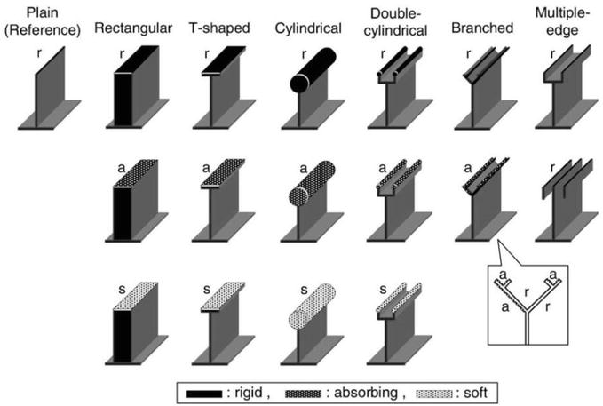

#### Figure 1.

Different types of noise barriers [4].

In Toledo et al. [[8](https://www.intechopen.com/chapters/72748#B8)] a procedure was proposed for improving the acoustic efficiency of noise barriers using top-edge devices. Furthermore, in Toledo et al. [[9](https://www.intechopen.com/chapters/72748#B9)] a procedure was developed for the optimization of well-based designs on the top of road barriers with both thick and very thin bodies by coupling a genetic algorithm with a 2D Dual BEM code. In addition, when placing a noise barrier in residential areas, studies have shown that it is also essential to keep in mind the “visual pleasantness” of the noise barrier which is the parameter introduced in Maffei et al. [[10](https://www.intechopen.com/chapters/72748#B10), [11](https://www.intechopen.com/chapters/72748#B11)].

Grubeša et al. [[12](https://www.intechopen.com/chapters/72748#B12), [13](https://www.intechopen.com/chapters/72748#B13)] have addressed the problem of economic feasibility of building noise barriers of various shapes and materials. Research and calculations done in this paper suggest a new specific noise barrier cost parameter (Ke) that must be taken into account during the optimization process of noise barrier shapes and materials while using computational calculations and optimization methods.

### 1.1 Noise level reduction with noise barriers

There are three basic parameters which describe noise barriers: insertion loss (IL), transmission losses (TL) and barrier absorption coefficient. Noise barriers can be defined as a certain sound “obstacle” between the sound source and the observer, i.e. the sound propagates around and over noise barriers. However, in real-case scenarios, the sound propagates also through the noise barrier, which is usually neglected, i.e. the sound proportion passing through the barrier is substantially smaller than the sound proportion which will cross over and around the noise barrier. The noise level reduction achieved by the installation of noise barriers is often called an additional noise level reduction, since the noise level will be primarily reduced due to the distance from the source and the air absorption and furthermore because the noise barrier itself. When quantifying noise reduction, a parameter, entered losses, is also often used and is defined as the noise level reduction arisen from the installation of noise barrier (insertion loss). It represents the difference between the sound pressures pp and pn , which are measured at the observer location before and after the noise barrier is placed, with the same ground configuration and position of the source and receiver, calculated according to the expression in [Eq. (1)](https://www.intechopen.com/chapters/72748#E1). This parameter is usually used for comparison of different noise barrier performances:

IL=−20loglog(pppn)��=−20loglog���� E1

The noise reduction parameter which arises from the installation of the noise barrier depends on the shape and material of the noise barrier, the frequency and type of sound source, the position of the noise barrier with respect to the source and the observer and the absorption properties of the soil on both sides of the noise barrier. The noise barrier effectiveness directly depends on the frequency of the sound propagating over it, and therefore the parameter insertion loss (IL) is also frequency dependent.

The noise barrier sound-absorbing properties are qualified according to EN 1793-1 [[14](https://www.intechopen.com/chapters/72748#B14)], while the airborne sound insulation index which corresponds to the transmitted noise barrier losses is defined in EN 1793-2 [[15](https://www.intechopen.com/chapters/72748#B15)].

### 1.2 Noise barrier types

There are three basic types of noise barriers. These are ground-mounted noise barriers, structure-mounted noise barriers and a combination of the first two types. Ground-mounted noise barriers are constructed of natural earth materials such as earth, stone, rocks or gravel. This type of noise barriers is typically constructed from excess materials in a noise-protected location, and source and availability of such natural materials are factors that can significantly affect the cost of such noise protection. Ground-mounted noise barriers take up more space than structure-mounted noise barriers. The reason for this is the slope of the embankment, which must gradually increase in order to maintain the stability of the whole structure. The increase is defined by the ratio m:n, where m is growth in the horizontal direction and n is growth in the vertical direction. For most embankments, the ratio is 2:1 or 1.5:1, while for stone embankments, the increase is usually 1:1.

Structure-mounted noise barriers or commonly called just noise barriers can be:

* Panel, shown in [Figure 2](https://www.intechopen.com/chapters/72748#F2).
* Brick and masonry, shown in [Figure 3](https://www.intechopen.com/chapters/72748#F3) [[16](https://www.intechopen.com/chapters/72748#B16)].
* Freestanding which can be:
  + Cast concrete at the installation site, shown in [Figure 4](https://www.intechopen.com/chapters/72748#F4) [[16](https://www.intechopen.com/chapters/72748#B16)].
  + Concrete blocks manufactured under controlled conditions then delivered and positioned at the installation site, shown in [Figure 5](https://www.intechopen.com/chapters/72748#F5).
  + Green vertical gardens, shown in [Figure 6](https://www.intechopen.com/chapters/72748#F6).

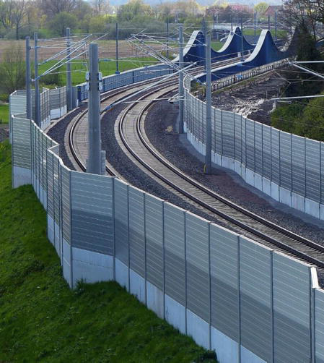

#### Figure 2.

Panel noise barriers.

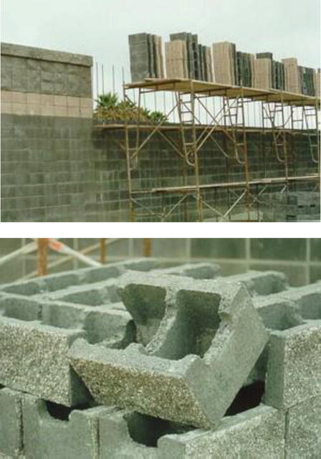

#### Figure 3.

Brick and masonry noise barriers.

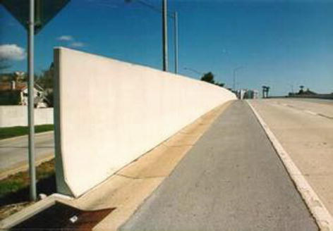

#### Figure 4.

Cast-in place noise barriers.

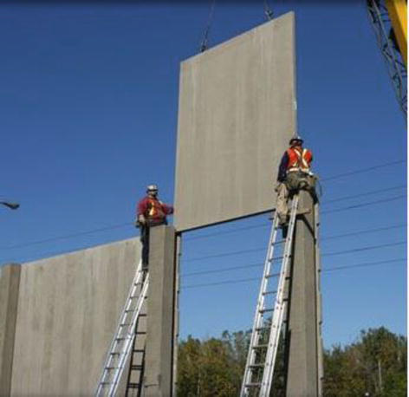

#### Figure 5.

Precast concrete noise barriers.

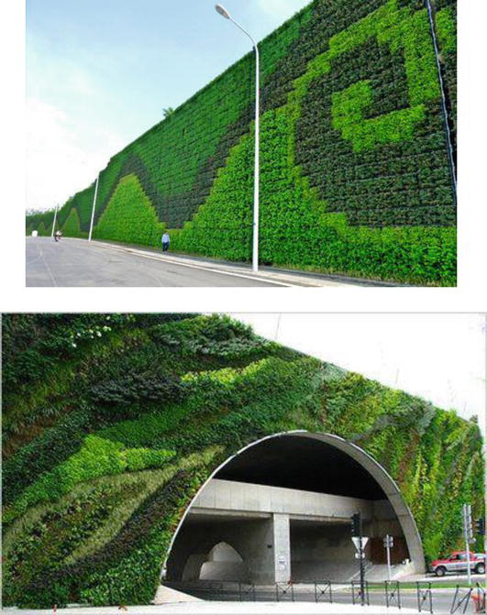

#### Figure 6.

Green vertical noise barriers.

#### 1.2.1 Panel noise barriers

Panel noise barriers usually consist of a board or panel, which can be wooden, metal or concrete, and it can be constructed out of one piece, or it can be assembled at the place of noise barrier installation from several components. The panels are mounted between the base posts. The basic elements of this noise barrier type are the post and the elements which attach it to the foundation, the panels and the elements which attach the panels to the posts.

There are several ways to set up or build a foundation for posts:

* Reinforced concrete foundation with a post anchored to the top of the foundation using anchor bolts.
* Reinforced concrete foundation where the post is partially embedded in the concrete mass during concreting.
* Continuous foundation wall.
* Unreinforced concrete foundation with post submerged to full depth of foundation.
* Wooden posts dug into drilled cylindrical holes with stone fill.

#### 1.2.2 Brick and masonry noise barriers

Brick and masonry noise barrier units are constructed out of either finished brick or masonry made of precast concrete blocks. Both types of noise barriers can be built at the installation site (by hand or machine), or they can be prefabricated in the form of blocks which will be assembled at the installation site. The construction of the noise barriers at the installation site allows greater flexibility and better adaptation to the terrain on which the noise barriers are placed, while the advantage of blocks or modules manufactured in advance in a controlled environment is greater uniformity, better durability and regularly lower costs. A disadvantage of such blocks or modules is the need to allow access and space to work machines (e.g. cranes and transport vehicles) at the installation site area in order to enable the assembling of the whole noise barrier.

#### 1.2.3 Free standing noise barriers

Free standing noise barriers can be concrete noise barriers moulded at the installation site. The process of building them involves digging the ground for support, laying down a steel reinforcement, pouring concrete, surface treatment and concrete hardening. In this particular construction, the casting and later hardening of concrete are carried out in different weather conditions, which can affect the quality of the final product. The advantage of these noise barriers is the fact that the shape and method of installation can be fully adapted to the terrain, which is the reason why these noise barriers are most commonly used on bridges and viaducts. An additional advantage of such noise barriers is their high structural strength and resistance to damage, which is why, alongside the noise protection and reduction function, they are very often used as retaining walls for separating traffic lanes for safety reasons.

Free standing noise barriers can also be precast or premanufactured, i.e. concrete panels are factory-made under controlled conditions and then delivered to the installation site where they are installed (please see [Figure 6](https://www.intechopen.com/chapters/72748#F6)). Furthermore, free standing noise barriers can be designed as green vertical noise barriers which are shown in [Figure 7](https://www.intechopen.com/chapters/72748#F7). Currently green vertical noise barriers are becoming more and more popular in cities because, in addition to reducing noise, they also reduce air pollution and they do not take up additional space, i.e. they are built into existing freestanding walls or facades.

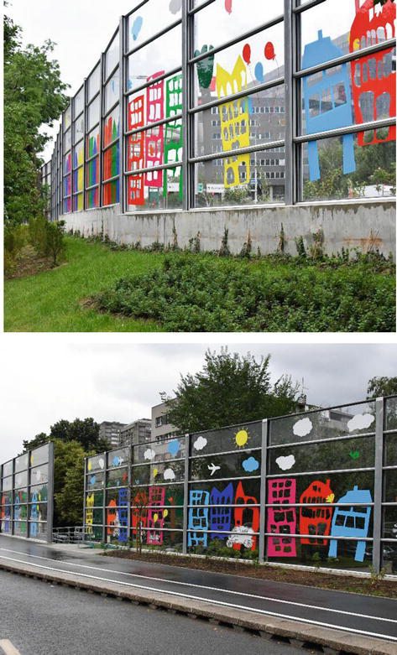

#### Figure 7.

An example of a transparent noise barrier on expressway.

To conclude, all of the aforementioned types of noise barriers are used as a measure of protection against traffic noise, while the choice of the noise barrier itself depends on the noise level at the location where the noise barrier is installed (i.e. acoustic properties of the sound source). In addition, the selection depends on the position of the noise barrier itself (distance of the noise barrier from the sound source and the receiver) and the allowed noise barrier height.

### 1.3 Material features

The noise barrier construction can be made of different materials. It is possible to construct a noise barrier with only one material; however, more often the construction of noise barriers consists of several different materials. The choice of materials depends on several basic factors: acoustic properties, type and level of noise sources from which we are protecting a certain space, mechanical properties, aesthetic requirements on both sides of the noise barrier, regulations and the cost of an investment in noise protection for a certain space. In addition to the above-mentioned and described basic materials (concrete, metals, wood, etc.), sound-absorbing materials (e.g. stone wool) are often used in practical case scenarios. Such materials can be used as noise barriers’ fill and with their sound absorption properties increase the noise barrier efficiency.

#### 1.3.1 Concrete

Concrete is one of the most commonly used building materials. Concrete cast into blocks which are transported to the installation site or cast at the installation site is considered as one of the most durable construction. It is robust and can withstand high temperatures, strong sunlight, moisture, ice and salt. It is quite easy to shape and colour; thus, its appearance can vary. The versatility of concrete also relates to the shape and size of the slabs that can be produced (cast in place, prefabricated concrete blocks). In addition, concrete enables various installation techniques.

#### 1.3.2 Metals

Three types of metal are most commonly used while constructing a noise barrier: steel, aluminium and stainless steel. Steel is the cheapest and most common of all metals used generally in construction. Thus, it is also generally used in the noise barrier construction, especially combined with concrete. Steel consists of a mixture of iron ore, coal and a small amount of other metals, while the ratio of the constituents varies depending on the desired physical properties.

For structures that require a slightly lower mass, aluminium is used, mainly as a light alloy with additives of manganese, silicon, copper and/or magnesium. Depending on the type of elements added to the aluminium in the alloy and their ratio, different mechanical, thermal, industrial and acoustic properties are obtained. Aluminium and its alloys are weatherproof and can be easily coated and anodized in different colours, making them suitable for installations with specific aesthetic requirements.

Stainless steel, which is a low carbon alloy with a minimum of 10.5% chromium, and is often mixed with nickel, molybdenum and titanium, is a very durable and resistant to corrosion due to its chromium alloy’s ability to bind to oxygen atoms from the air, thus creating an invisible thin protective film on the metal surface that protects the metal from oxidation and damage. Since stainless steel is almost completely resistant to corrosion, its surface does not need to be coated or additionally protected and is often used in areas with high humidity, especially if the noise barrier is in contact with or near seawater.

Metal panels have a great advantage over concrete materials, which is their light weight. Their low weight makes them particularly useful for vertical extensions of existing walls, that is, for installation on existing retaining walls and for installation on bridges. Due to their simple manufacturing and easy assembly, either by attachment or welding, they are often used on bridges and viaducts attached to the existing load-bearing structural elements of the bridge itself.

#### 1.3.3 Wood

Different types of wood can be used in the production of noise barriers. The design range of constructions varies from simple, i.e. consisting of several wooden panels, to very complex structures made of multiple wooden pieces that can often be made of different types of wood. Wood is a natural, environmentally friendly material, which is very easy to process and has a low mass. Panels of wood that are creating a noise barrier parts can be installed piece by piece at the installation site or may be partially assembled on the ground prior to installation. Such noise barriers are easy to disassemble or remove, and the wood is from the aesthetic point of view, a very accepting and pleasing material to the environment. In addition, it does not conduct electricity. A significant problem with noise barriers made of wood is its flammability, and furthermore the smoke and gases resulting from its combustion are toxic. In addition to burning, the process of wood rotting in contact with moisture is very fast, which makes it necessary to protect it with a chemical preservative, which adds complexity to the process of producing the noise barriers and the need for more frequent maintenance. Wood products are not dimensionally stable and tend to change shape, which causes open cracks between joints, and the tendency to change shape increases with the dimensions of the wooden piece of the noise barrier itself.

#### 1.3.4 Transparent panels

Transparent panels can be made of glass or plastic materials, such as Plexiglas, Lexan, Acrylic, etc. which is shown in [Figure 7](https://www.intechopen.com/chapters/72748#F7).

Glass panels are usually made of tempered or laminated tempered glass. Tempering the glass strengthens the glass, and therefore such product becomes more resistant to breakage. If broken, the shards are small and grainy, with pieces generally no larger than 12 mm, which is far safer than knife-like shards that result from breaking glass that has not been heat treated. In addition to tempering, the glass panel can also be laminated. This type of glass is manufactured by inserting a translucent, rubber and flexible interlayer between the two tempered glass panels. When such glass breaks, small granular fragments are formed which remain glued to the interlayer.

Transparent panels are ideal for reducing or completely eliminating the visual impact of a noise barrier; however, their costs can be 20 times higher than those made of concrete or steel. The justification for their high cost can be found in improving safety in places where opaque noise barriers can have a negative effect on visibility. These types of panels are more sensitive to damage from flying debris and abrasive action as a consequence of the sandblasting effect that is inevitably due to the swirling dust that is always present on the pavement layer.

#### 1.3.5 Plastic

There are several types of plastic materials available and often used in the construction of noise barriers: polyethylene, PVC (polyvinyl chloride) and fibreglass. Plastic panels can be installed in almost any situation due to their extremely low mass, easiness to mould and weatherproof features. Bearing in mind all of the aforementioned, they are increasingly used for the construction of noise barriers, especially those of a more complex shape. The problem with plastic materials is a slightly lower structural strength and flammability, i.e. the smoke and gases produced by the combustion of plastics are very toxic.

#### 1.3.6 Composite materials

Composite materials for noise barriers can be defined as any product composed of two or more “basic” materials, for example, wood mixed with concrete and then placed on a concrete foundation. By combining basic materials, the characteristics of the final product (noise barriers) and its durability, and even in some cases safety, are altered.

### 2.4 Noise barriers transmission loss (TL)

Typical values of the noise barriers transmission loss (TL) parameter when looking at the A-weighted characteristic are from 10 dBA to 15 dBA. Noise barriers should be constructed of materials with a minimum density of 20 kg m2. A density of 20 kg/m2 can be achieved by lighter and thicker or heavier and thinner materials (i.e. higher material density enables a thinner material). [Table 1](https://www.intechopen.com/chapters/72748#tab1) gives the approximate TL values for some common materials, tested for a typical A-weighted highway traffic frequency spectrum [[16](https://www.intechopen.com/chapters/72748#B16)]. These values can be used as a rough guideline in designing noise barriers. For more accurate values, one would need to find material testing reports from authorised laboratories.

THANK YOU…

.

Bottom of Form